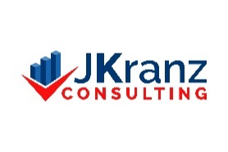™

The services available from JKranz Consulting are driven by the needs of the client. The fee structure is customized based on factors including scope, scale, and duration of a project; budget cycle, concerns; and additional resources if needed.

It is flexible to make the services more accessible to Non-Profits.

Thank you.

Janet Kranz